Natirar Park

Volunteer Tree Planting

Join Raritan Headwaters Association and Somerset County Parks Commission as we restore the stream corridor along the North Branch Raritan River. Trees help stabilize streambanks, prevent erosion, control flooding, provide habitat for wildlife, and provide shade which helps maintain cooler temperatures for fish and other aquatic life. Please join us for this important endeavor!

Thursday
May 11
12pm-3pm

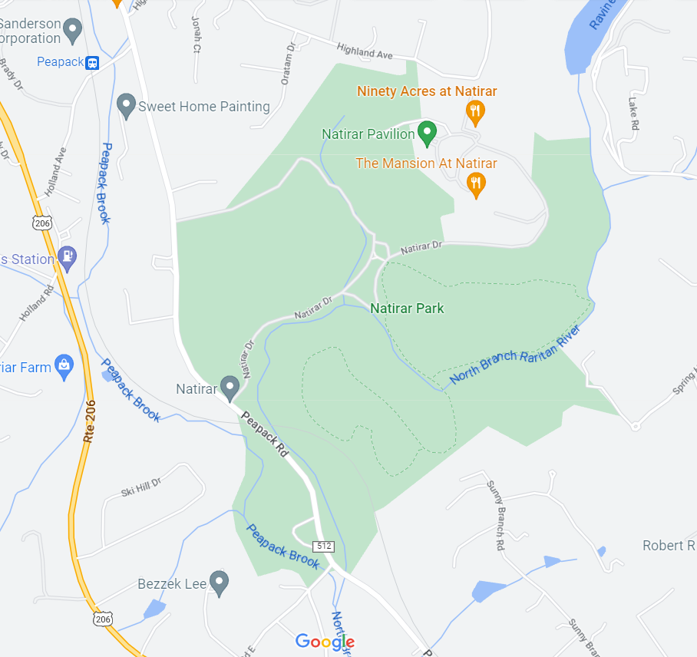

Please register in advance for this event by visiting RHA’s events calendar:
https://www.raritanheadwaters.org/events-happenings/
To coordinate a large corporate group, please contact our Volunteer Coordinator, Debbie Newcomb dnewcomb@raritanheadwaters.org
For questions about the planting, contact our
Restoration Coordinator, Robert Lucas rlucas@raritanheadwaters.org

